MSIPL Website Draft

Tagline options [Should Discuss]
MSIPL - Legacy of Soap Innovation & Excellence
(25 years Legacy of Soap Innovation & Excellence)("One Factory. A Million Clean Homes." )A 25-Year Legacy of Soap Innovation and Excellence. Built on heritage and designed for today
Shashi - Trusted By Families. Crafted with Pride
Savaal - Clean Solutions for Every Indian Home
(Where there is Savaal, there is victory. )
Shashi+ - Premium Care. Proven Performance.
(Engineered) for Clothes that Deserve Better Care)

25 Years Badge - Celebrating 25 Years of Crafting Quality Soaps, Silver Jubilee of Excellence, 25 Years of Trusted Cleanliness (Eg. only, Should Discuss)
*Add a visually appealing “25 Years” badge or ribbon on product packaging images, in the top nav bar, or pinned near the header—this reinforces legacy and trust.

Navigation Bar:

Home
About Us
Brand & Products
Quality Assurance
Distributors
Shop Online
News & Blog
Career
Contact.

HOME:

Hero Section (Poster)= Would need better colour play to highlight the products.
Maybe Can Have -’ Celebrating 25 Years of Clean Living’ Badge There
Maharaj Soaps Industry Pvt. Ltd. (MSIPL) has been redefining hygiene in Indian homes with trusted soap solutions since 2000.
CTA Requirement for = Explore our products.

Welcome to Maharaj Industries
Since its inception in 2000 by Dr. Raviraja M.E, MSIPL has emerged as a trusted manufacturer and supplier of detergent soaps, powders, and liquids. Evolving from Maharaj Industries into a private limited company in 2010, we have expanded our reach across India with a strong commitment to innovation, quality, and customer satisfaction.
Our journey is built on excellence, reliability, and a vision to provide every home with affordable, effective, and safe cleaning solutions.
(Since its establishment in 2000 by Dr. Raviraja M.E, MSIPL has been a trusted manufacturer and supplier of detergent soaps, powders, and liquids. Transitioning from Maharaj Industries to a private limited company in 2010, we have expanded our operational presence across India (& other countries) driven by an unwavering commitment to innovation, quality assurance, and customer satisfaction.)

[ Existing = Maharaj Soaps Industry Private Limited (MSIPL) is known for its distinguished manufacturer and supplier of detergent soaps, powder & liquids. Maharaj Industry was established in the year 2000 by Dr. Raviraja.M.E, Chairman & Managing Director, After a successful year of journeys in 2010 it has become Maharaj Soaps Industry Private Limited (MSIPL). Today the company offers a wide array of products to customers that are not only best in terms of quality and performance but also meet complete customer expectations.
Our company has made its mark as a prominent provider of a diverse range of products and has been known for quality. Our company vigorously focuses on customer requirements and delight customers with its premium quality products. With this aim, it has successfully catered its products to customers which have been highly appreciated in the market.]

Our Numbers
Customers Served
Years of Legacy
Branches / Factories / Distributors

Our Brands
Each In a Box, When clicked on it, it has to redirect to the Brand and Products Page.

Why Choose us?

25 Years of Trust & Legacy
Expertise & Innovation in Every Bar (Product)
Certified Quality Assurance
Affordable, Effective, & Accessible
Sustainable Practices, Always
Safe for You & Your Family
Customer Satisfaction Is Our Promise

ABOUT US

Chairman's Message
Maharaj Industries has come a long way since its inception in the year 2000. It gives me great pleasure to reflect on the journey and success we have achieved over the past decades. The cornerstone of our growth has been the unwavering commitment to our core values — Integrity, Respect, Teamwork, Motivation, Excellence, and Innovation. These values are deeply embedded in our organizational culture and guide us in every endeavor.
Today, we are proud manufacturers of a diverse range of products under the renowned brand names SHASHI and SAVAAL. Our continued success is a testament to the quality and trust we have built over the years.
In alignment with the saying, “success breeds success”, the accomplishments of Maharaj Industries paved the way for the establishment of our new venture — Maharaj Soaps Industry Private Limited, launched in 2010. This company has added a new dimension to our business, enabling us to reach greater heights. We are among the pioneers in introducing the Pink Detergent Cake, which has become one of the best-selling detergent products in India.
With a strong market presence across the country, we have successfully diversified our operations into key sectors including FMCG Manufacturing, E-commerce, Retail, Education, Logistics, and more. As we continue to grow and evolve, we remain committed to delivering quality, value, and innovation in everything we do.
— Dr. Raviraja M.E,
Founder & CMD, MSIPL

Our Vision: To exceed customer expectations by delivering excellent products and outstanding services throughout the nation.

Our Mission: To aim to deliver high-quality, innovative products and services through our trusted brands like SHASHI and SAVAAL, guided by our core values and an unshakeable commitment to quality, safety, and sustainability.

OUR VALUES
INTEGRITY - "We lead with high ethics, honesty, and fairness"
RESPECT - "We honor the rights and beliefs of our employees, our customers, our suppliers and our community. We believe in the saying, “Treat others as you would like to be treated.”
TEAM WORK - “We promote and support individuals to come up as a team with diverse whiz.”
MOTIVATION - "We recognize, reward, and celebrate the achievements of the individuals and teams."
EXCELLENCE - "We are dedicated to giving the best in everything we do in our organization."
INNOVATION - "We innovate from product to process continuously. We are creative in delivering value to our customers, our fellow associates, and to our community."

BRAND & PRODUCTS

( Has to drop down 3 brand Which will again drop products/segment in each section)
Shashi
Savaal
Shashi +

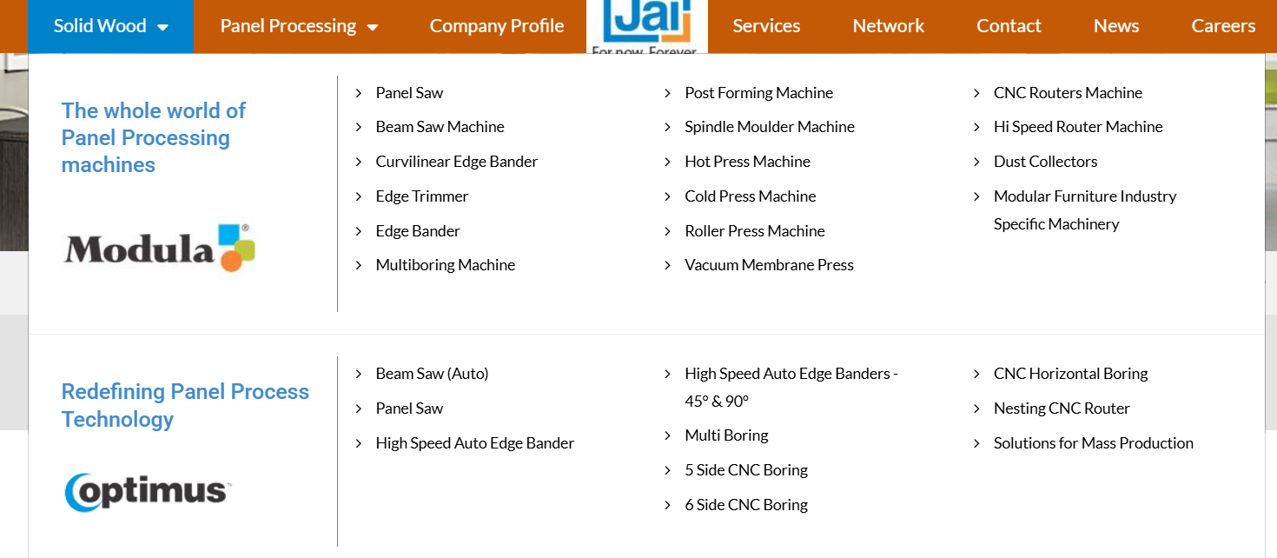

REFERENCE IMAGE ONLY.

When clicked on the segment / product group it can open to the products with HD image can have Order Option and Product detail option like - key ingredients, benefits, usage scenarios, weight/pack size, certification.

QUALITY ASSURANCE (Optional)
At MSIPL, quality is not merely a benchmark; it represents an absolute commitment.
Our manufacturing and quality control processes are fully certified to guarantee product safety and foster consumer trust.

Official certifications and relevant documentation may be displayed to substantiate our compliance with rigorous safety and quality standards.

Unwavering Focus on Hygiene: From Production to Performance
Legacy of Trust: Before entering an Indian household, every Shashi product undergoes a rigorous evaluation process refined over 25 years of industry-leading expertise and innovation.
MSIPL Quality Assurance & Commitment:
🧪 Comprehensive Batch Testing – We extend beyond standard sampling protocols; each production run is meticulously verified for lathering efficiency and cleaning efficacy before distribution.
🏭 End-to-End Operational Control – Our supply chain is strictly managed from raw material procurement to the retail shelf, ensuring that excellence is never compromised.
👨‍👩‍👧 Engineered for Indian Households – Designed for practical utility, our soaps remain highly effective in hard water conditions while being safe and gentle for families and sensitive skin.
📊 Evolution through Innovation – Our operational standards are dynamic; we continuously integrate consumer feedback and seasonal insights to refine our processes and surpass industry benchmarks.
"Our manufacturing protocols strictly adhere to rigorous internal quality controls. At MSIPL, we do not merely satisfy industry benchmarks—we consistently strive to redefine corporate excellence."
Why Partner with MSIPL?
- ✅ Strong Brand Portfolio – Widely recognized and trusted by customers
- ✅ High Demand Products – Proven performance and market relevance
- ✅ Attractive Margins – Competitive pricing for high-profit potential
- ✅ Marketing & Sales Support – Promotional materials and on-ground campaigns
- ✅ Robust Supply Chain – On-time delivery and consistent stock availability
- ✅ Exclusive Regional Rights (based on volume and territory)
NEWS & BLOG

Existing media page can be brought here with an addition of Blog, events, etc.

CAREER:
- Name
- Email
- Phone
- Location (City, State)
- Upload Resume

CONTACT US
(Social Media logos & phone number )
25 Years of Excellence in Soap Innovation. Built on Legacy, Designed for Today.
Clean Solutions for Every Indian Home.

